Theme/Term | A twist in the tale Autumn 1 |  | Creation & conservation Autumn 2
Writing Root /  Spelling Seed Text | 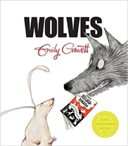  Wolves  Emily Gravett | 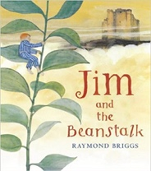  Jim and the Beanstalk  Raymond Briggs | 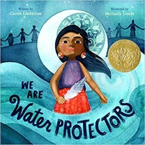  We Are Water Protectors  Carole Lindstrom |  | 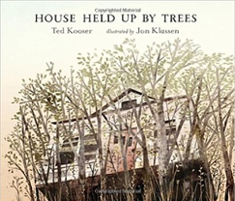  House Held Up By Trees  Ted Kooser
Outcomes | Non-chronological leaflets  Captions, information writing, character descriptions and comparisons | Sequel stories  Narrative retellings (including dialogue), thought bubbles, informal letters | Environmental campaign  List poems, non-chron reports (animals), chronological reports (life-cycles), character descriptions, protest signs |  | News reports  Descriptive non-fiction, life-cycles, instructions for seed packets
Literary Leaf Text | 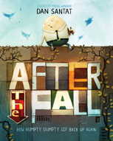  After the Fall  Dan Santat |  | 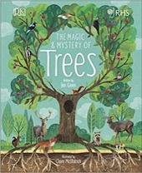  The Magic and Mystery of Trees  Jen Green
Theme/Term | Bravery vs. fear Spring 1 |  | Change & relationships Spring 2
Writing Root /  Spelling Seed Text | 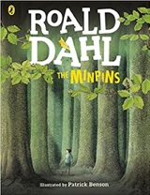  The Minpins  Roald Dahl |  | 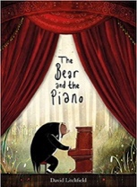  The Bear and the Piano  David Litchfield |  | 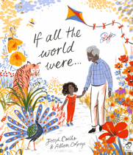  If All the World Were…  Joseph Coelho
Outcomes | Own version adventure narratives  Danger posters, setting descriptions, character descriptions, information reports, postcards |  | Own version narratives about bravery  Letters of advice, short news reports, writing in role, retellings, information posters |  | Non-narrative read-aloud poem  Writing in role, diaries, letters of advice, short explanations
Literary Leaf Text | 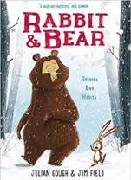  Rabbit and Bear by Julian Gough & Jim Field |  | 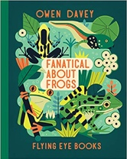  Fanatical about Frogs  Owen Davey
Theme/Term | Fictional Worlds & fantasy Summer 1 |  | Urban metropolis Summer 2
Writing Root /  Spelling Seed Text | 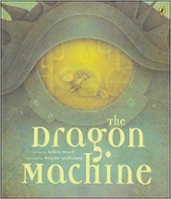  The Dragon Machine  Helen Ward | 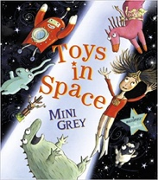  Toys in Space  Mini Grey | 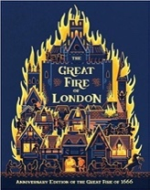  The Great Fire of London  Emma Adams | 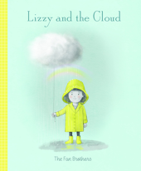  Lizzy and the Cloud  The Fan Brothers
Outcomes | Own version dragon stories  Dragon guides & encyclopaedia, letters of advice, dragon machine explanations, shopping lists, descriptions, letters | Own version fantasy world narrative  Found posters, diary entries, speech bubbles, notes of advice, space logs, invitations, fantasy setting descriptions | Information booklets  Persuasive poster, warning posters (instructional writing), speech bubbles, letter of advice, certificates | Guidebooks  Descriptions, adverts / market stall pitches, letters of advice, postcard in role
Literary Leaf Text | 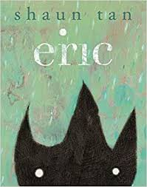  Eric  Shaun Tan |  | 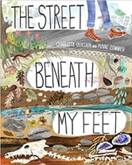  The Street Beneath my Feet  Charlotte Guillian

