Theme/Term | Magic & wonder Autumn 1 |  | Dreams & curiosity Autumn 2
Writing Root /  Spelling Seed Text | 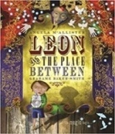  Leon and the Place Between  Angela McAllister | 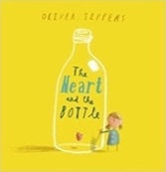  The Heart and the Bottle  Oliver Jeffers | 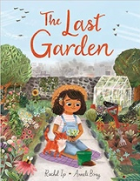  The Last Garden  Rachel Ip
Outcomes | Own version fantasy narratives  Persuasive posters, setting descriptions, thought bubbles/diaries, dialogue | Own version ‘dilemma’ narratives Character descriptions, narrative retellings | Own version extended narrative  Setting descriptions, advertisement/ poster, retelling, instructional flyer, social media updates, dialogue
Literary Leaf Text | 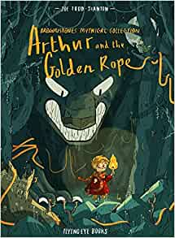  Arthur and the Golden Rope  Joe Todd Stanton |  | 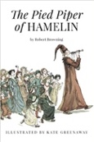  The Pied Piper of Hamelin  Robert Browning
Theme/Term | Disaster, hope & healing Spring 1 |  | Overcoming adversity Spring 2
Writing Root /  Spelling Seed Text | 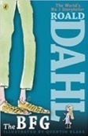  The BFG  Roald Dahl |  | 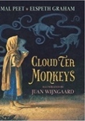  Cloud Tea Monkeys  Mal Peet & Elspeth Graham | 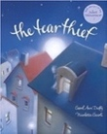  The Tear Thief  Carol Ann Duffy
Outcomes | Own version fantasy narratives Recount (diary entry), character descriptions, wanted posters, new chapters, instructions |  | Non-chronological reports  Descriptions, ‘how to’ guides (instructions), letters, discussions | Newspaper Article  Shared poem, diary entry, persuasive poster, letter of explanation, discussion
Literary Leaf Text | 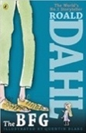  The BFG  Roald Dahl |  | 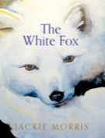  The White Fox  Jackie Morris
Theme/Term | From mystery to discovery Summer 1 |  | Confidence & caution Summer 2
Writing Root /  Spelling Seed Text | 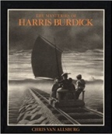  The Mysteries of Harris Burdick  Chris Van Allsberg | 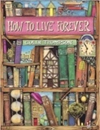  How to Live Forever  Colin Thompson | 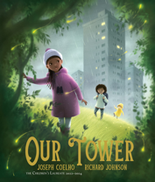  Our Tower  Joseph Coelho
Outcomes | Extended fantasy narrative  Setting description, short first person narrative, dialogue, speech, action scene | Prequels  Lost posters, dialogue, setting and character descriptions, ledger entries, instructions, letters of warning | Extended fantasy narratives  Poems, setting descriptions, diary entries, dialogue, letters of thanks
Literary Leaf Text | 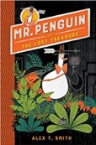  Mr Penguin and the Lost Treasure  Alex T. Smith |  | 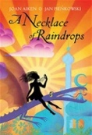  A Necklace of Raindrops  Joan Aiken

