Theme/Term | Finding Freedom Autumn 1 |  |  | Invention & innovation Autumn 2
Writing Root/  Spelling Seed Text | 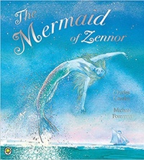  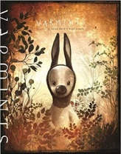  Varmints  Helen Ward | The Mermaid of Zennor  Charles Causley |  | 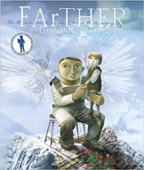  FArTHER  Grahame Baker Smith | 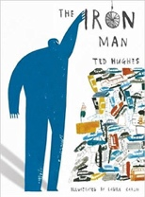  The Iron Man  Ted Hughes
Outcomes | Explanations of a life cycle  Diary entries, instructions, letters, descriptions, speeches | Own version legends  Information booklets, retelling from a different perspective, letters, tourist guides updates, dialogue |  | Sequel stories  Retellings, recounts (postcards), setting descriptions, diary entries, instructions | Mystery narratives  Character descriptions, short news reports, letters of advice, menus (using descriptive devices), poetry
Literary Leaf Text | 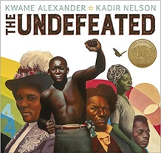  The Undefeated  Kwame Alexander |  |  | 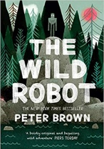  The Wild Robot  Peter Brown
Theme/Term | Darkness & light Spring 1 |  |  | Taking courage Spring 2
Writing Root/  Spelling Seed Text | 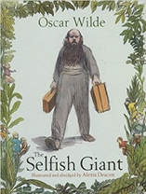  The Selfish Giant  Oscar Wilde |  |  | 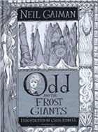  Odd and the Frost Giants  Neil Gaiman
Outcomes | Own version narratives about kindness  Letters, first person recounts, diaries, letters, posters, reports |  |  | Retellings - alternative perspective  Narrative recounts, character and setting descriptions, letters, short explanations
Literary Leaf Text | 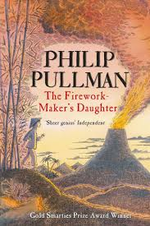  The Firework Maker's Daughter  Philip Pullman |  |  | 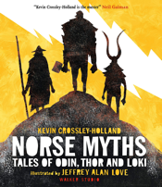  Norse Myths  Kevin Crossley-Holland
Theme/Term | Unearthing Civilsations Summer 1 |  |  | Different worlds Summer 2
Writing Root/  Spelling Seed Text | 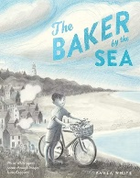  The Baker by The Sea Paula White |  | Shackleton’s Journey  William Grill  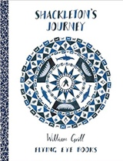 | 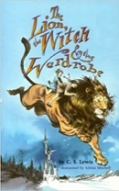  The Lion the Witch and the Wardrobe  C. S. Lewis
Outcomes | Tourist brochures  Job applications, advertisements, setting descriptions, letters in role |  | Tutankhamun biographies  Reports, instructions, character descriptions, diaries, newspaper, posters | Own version narratives (set in other worlds)  Poems, eyewitness reports, imaginary conversations, writing in role
Literary Leaf Text | The Last Firefox  Lee Newbery |  |  | The Lion the Witch and the Wardrobe  C. S. Lewis |  | 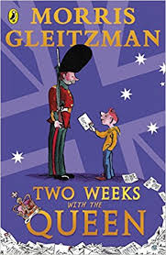  Two Weeks with the Queen  Morris Gleitzman

