Theme/Term | Ambition & desire Autumn 1 |  |  | Power vs. principles Autumn 2
Writing Root/ Spelling Seed Text | 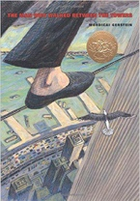  The Man Who Walked Between the Towers  Mordicai Gerstein |  | 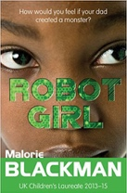  Robot Girl  Malorie Blackman | 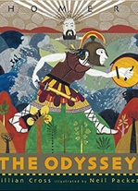  The Odyssey  Gillian Cross | 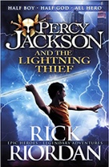  Percy Jackson  Rick Riordan
Outcomes | Biographies/autobiographies  Information writing (Wikipedia pages), letters of advice (formal), interviews, news report, persuasive speeches |  | Science-fiction narratives  Discussions, debates, dialogue, character comparisons, reviews | Epic stories Speeches (proclamation, persuasive, soliloquy), dialogue, missing scenes, postcards, adverts | Mythical narratives  Odes, soliloquies, setting descriptions, additional chapters, reports
Literary Leaf Text | 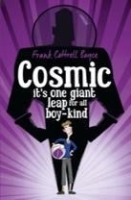  Cosmic Frank Cottrell Boyce |  |  | 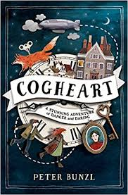  Cogheart  Peter Bunzl
Theme/Term | Belonging & equality Spring 1 |  |  | Legends & folklore Spring 2
Writing Root/  Spelling Seed Text | 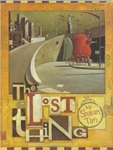  The Lost Thing  Shaun Tan | 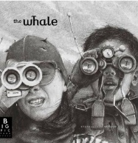  The Whale Ethan and Vita Murrow |  | 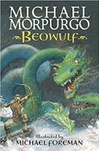  Beowulf  Michael Morpurgo
Outcomes | Own version narrative  Diaries, formal letters, adverts, character and setting descriptions, NC reports | Reported speech, speech and thought bubbles, description, recount in role, letter to a newspaper editor |  | Own version legends/missing chapters Letters of advice, diaries, dialogue, character and setting descriptions, action scenes, obituaries
Literary Leaf Text | 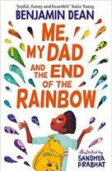  Me, My Dad and the End of the Rainbow  Benjamin Dean  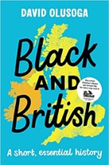 |  |  | 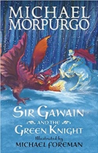  Sir Gawain and the Green Knight  Michael Morpurgo
Theme/Term | Lessons from history Summer 1 |  |  | Mystery & truth Summer 2
Writing Root/  Spelling Seed Text | 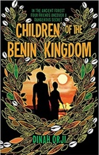  Children of the Benin Kingdom  Dina Orji |  | 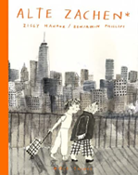  Alte Zachen  Ziggy Hanaor | 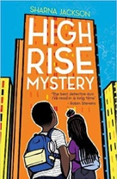  High Rise Mystery  Sharna Jackson |  | 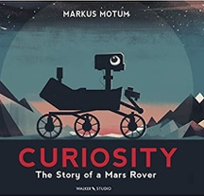  Curiosity  Markus Motum
Outcomes | Non-chronological reports  Informal letters, diaries, survival guides, eyewitness reports, story summaries |  | Analytical essay  Character descriptions, flashbacks, diary entries in role, short autobiographies | Extended stories Character & setting descriptions, police & newspaper report, dialogue, persuasive letters |  | Expanded explanations  NASA Proposals, information labels, short explanations, NASA logs, news reports
Literary Leaf Text | 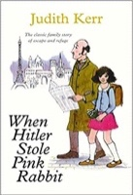  When Hitler Stole Pink Rabbit  Judith Kerr |  |  | 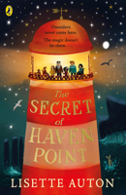  The Secret of Haven Point  Lisette Auton |  | 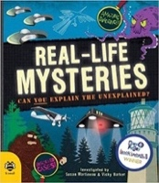  Real-life Mysteries Susan Martineau and Vicky Barker

