Theme/Term | Migration & movement Autumn 1 |  | Evolution & inheritance Autumn 2
Writing Root /  Spelling Seed Text | 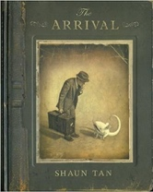  The Arrival  Shaun Tan | 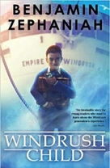  Windrush Child  Benjamin Zephaniah | 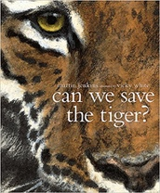  Can We Save the Tiger?  Martin Jenkins | 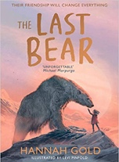  The Last Bear  Hannah Gold
Outcomes | Extended own version narratives  Letters, lists of rules, character descriptions, diaries, short playscripts, short reports, guides | Persuasive pitch to the local council  Thought bubble, informal letter, poem, diary entry, advice, informal letter | Discussion texts  Letters, explanations, persuasive posters, & speeches, simple poems | Newspaper article  Character profile, dialogue, monologue, logbook entry, scientific report
Literary Leaf Text | 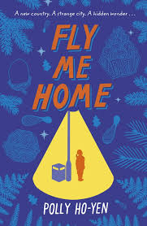  Fly Me Home  Polly Ho Yen |  | 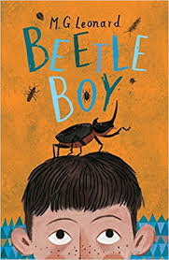  Beetle Boy  M. G. Leonard
Theme/Term | Enterprise & activism Spring 1 |  | Utopia vs. dystopia Spring 2
Writing Root /  Spelling Seed Text | 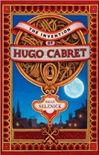  The Invention of Hugo Cabret  Brian Selznick |  | 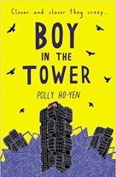  Boy in the Tower  Polly Ho-Yen
Outcomes | Biographies  Diaries, journalistic writing, flashback narratives, speeches, discussions, letters, film critiques |  | Own version narratives (past and present tense)  Journalistic writing, formal letters, non-chronological reports
Literary Leaf Text | The Invention of Hugo Cabret  Brian Selznick | 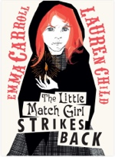  The Little Match Girl Strikes Back  Emma Carroll | 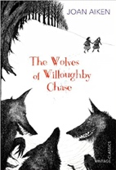  The Wolves of Willoughby Chase  Joan Aiken
Theme/Term | Fate vs. free will Summer 1 |  | Crossing borders Summer 2
Writing Root /  Spelling Seed Text | 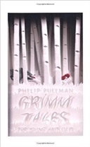  Grimm Tales for Young and Old  Phillip Pullman | 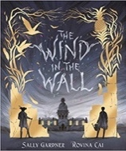  The Wind in the Wall  Sally Gardner | Rain Player  David Wisniewski  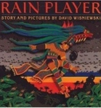 | 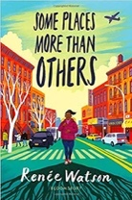  Some Places More Than Others  Renee Watson
Outcomes | Own version traditional tales  Retellings, character studies, monologues | Extended narrative  Posters, figurative writing, descriptions, old English letter | Analytical essays  Instructions, posters, missing scenes, diaries, debates | The Suitcase Project  A transition project to represent children including maps, recipes, poems, photos and a biography
Literary Leaf Text | Grimm Tales for Young and Old  Phillip Pullman |  | 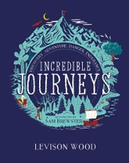  Incredible Journeys  Levison Wood |  | 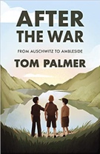  After the War: From Auschwitz to Ambleside  Tom Palmer

