Theme/Term | Outside Inside Autumn 1 |  | Knowing Yourself Autumn 2
Writing Root Text | Phonics and pre-requisite mark making.
Theme/Term | Talents & powers Spring 1 |  | Sowing a seed Spring 2
Writing Root Text | 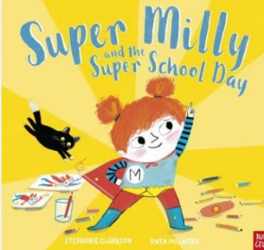  Super Milly and the Super School Day  Stephanie Clarkson |  | 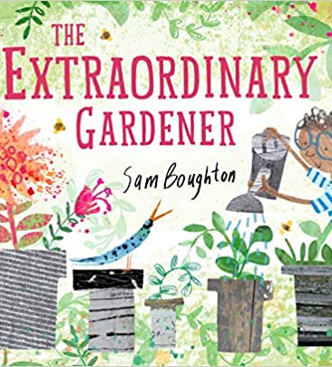  The Extraordinary Gardener  Sam Boughton
Outcomes | Alternative character version  Letters of encouragement; a retelling; song lyrics and job applications |  | Narrative inspired by the original text  Labels, letters of advice, instructions, narratives
Theme/Term | Strength of mind Summer 1 |  | Family & friends Summer 2
Writing Root Text | 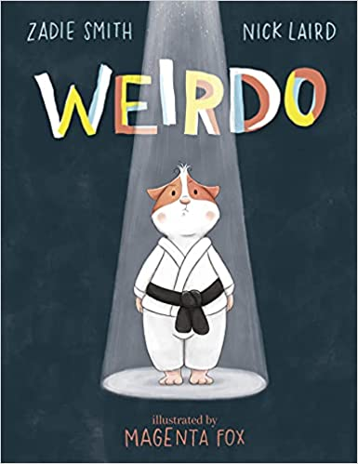  Weirdo  Zadie Smith and Nick Laird | 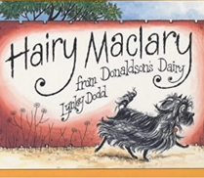  Hairy Maclary from Donaldson’s Dairy  Lynley Dodd | 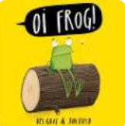  Oi Frog  Kes Gray | 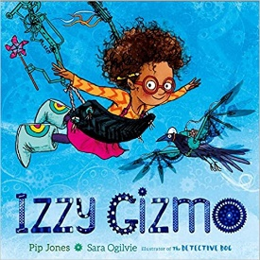  Izzy Gizmo  Pip Jones
Outcomes | Instructional guides to being brave  Writing in role, letters, captions and labels, narrative retellings | Alternative version narratives  Character description, writing in role, letters, leaflets | Own version rhyming narrative  Rhyming flip-books, questions, captions and labels | Simple explanation  Signage, letters of advice, lists, labelled diagrams

