Theme/Term | Journeys & exploration Autumn 1 |  |  | Heroes & villains Autumn 2
Writing Root /  Spelling Seed Text | 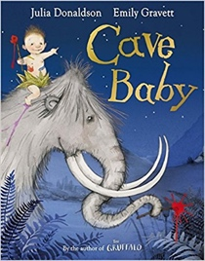  Cave Baby  Julia Donaldson and Emily Gravett |  | 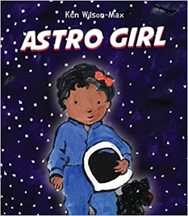  Astro Girl  Ken Wilson-Max | 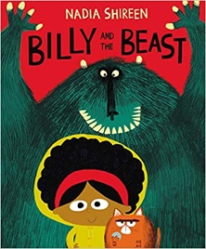  Billy and the Beast  Nadia Shireen | 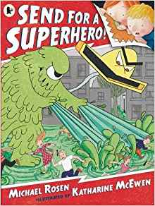  Send for a Superhero  Michael Rosen & Katharine McEwan
Outcomes | Narrative retellings  Labels and captions, informal letters |  | Fact files about being astronauts  Writing in role, commands, ‘how to’ guides | Own version ‘defeat a monster’ narratives  Wanted posters, summaries, emails, character descriptions, recipes | Own version superhero narratives  Wanted posters, letters, speech bubbles, diaries, emails, character descriptions
Theme/Term | Similarities & differences Spring 1 |  |  | Nature & environment Spring 2
Writing Root /  Spelling Seed Text | 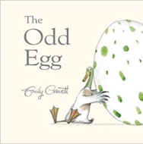  The Odd Egg  Emily Gravett |  |  | 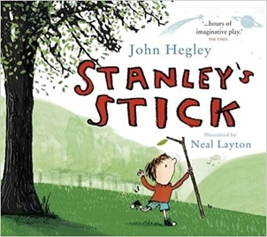  Stanley’s Stick  John Hegley and Neal Layton
Outcomes | Egg-spotter’s guides (non-fiction reports)  Thought and speech bubbles, diaries, letter, certificates |  |  | Own version narratives  Retellings, descriptions
Theme/Term | Friendship & kindness Summer 1 |  |  | Imagination & creativity Summer 2
Writing Root /  Spelling Seed Text | 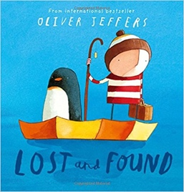  Lost and Found  Oliver Jeffers | 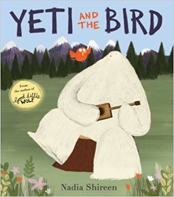  Yeti and the Bird  Nadia Shireen |  | 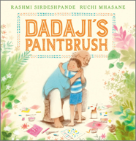  Dadaji’s Paintbrush  Rashmi Sirdeshpande |  | 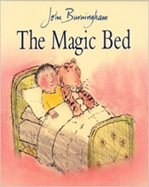  The Magic Bed  John Burningham
Outcomes | Own version ‘losing/finding’ narratives  Character descriptions, retellings, advice, instructions, non-chronological reports | Own version narratives about unlikely friendships  List of rules, letters, postcards, character descriptions |  | Own version narrative  Labels, captions, character comparisons, thought and speech bubbles, fact files |  | Own version fantasy stories  Setting descriptions, additional scenes, description of magical piece of furniture, lists

