Whole-school computing Map – Whitley Park Primary School – 2025.
Curriculum requirements:
Key Stage One | Key Stage Two
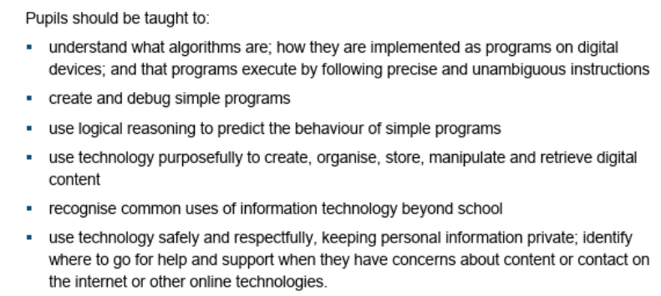 | 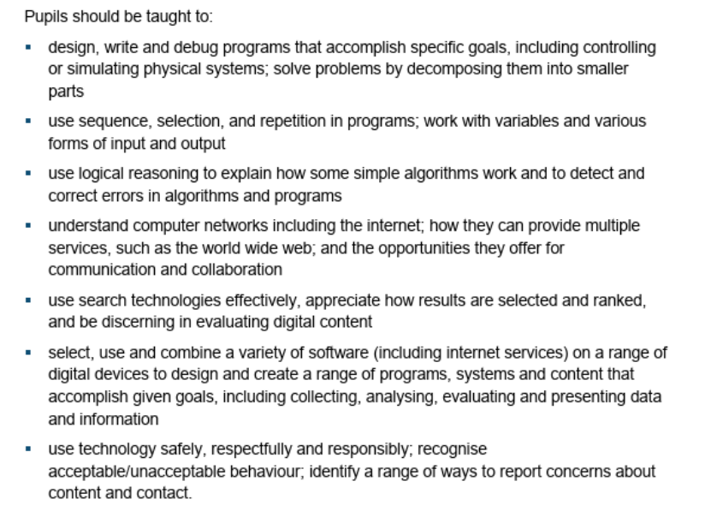

Year Group | Module 1 | Module 2 | Module 3 | Software and hardware requirements
Nursery
Reception
Year 1 | Unit 1 – Computing systems and networks – Technology around us. | Unit 3 – Programming A – Moving a Robot. | Unit 5 – Creating media – Digital Writing. | Module 1 –  Module 2 – Beebots or similar programmable floor robots.  Module 3 – Word processing software.
Year 1 | NC objectives – recognise common uses of technology beyond school; using technology purposefully; use logical reasoning to predict the behaviour of simple programs; use technology purposefully to create, organise, store and manipulate digital content; use technology safely and respectfully. | NC objectives – understand what algorithms are, how they are implemented, and that programs execute by following precise, unambiguous instructions; create and debug simple programs; use logical reasoning to predict the behaviour of simple programs. | NC objectives – use technology purpose purposefully to create, organise, store and manipulate digital content; use technology safely and respectfully; understand that programs execute by following precise, unambiguous instructions.
Year 2 | Unit 2 – Creating media – Digital Photography. | Unit 4 – Data and Information – Pictograms. | Unit 6 – Programming B – Programming quizzes (Year 1 animations). | Module 1 – Camera software on devices  Module 2 – j2e pictogram and j2e chart tools. Online.  Module 3 – Scratch Jr software.
Year 2 | NC objectives – use technology purpose purposefully to create, organise, store and manipulate digital content; use technology safely and respectfully; understand that programs execute by following precise, unambiguous instructions. | NC objectives – recognise common uses of technology beyond school; using technology purposefully; use logical reasoning to predict the behaviour of simple programs; use technology purposefully to create, organise, store and manipulate digital content; use technology safely and respectfully. | NC objectives – understand what algorithms are, how they are implemented, and that programs execute by following precise, unambiguous instructions; create and debug simple programs; use logical reasoning to predict the behaviour of simple programs.
Year 3 | Unit 1 – Computing Systems and networks – Connecting Computers | Unit 2 – Creating Media – Stop-frame Animation | Unit 6 – Programming [B] – Events and Actions in Programs | Module 1 –  Module 2 – iMotion software  Module 3 - Scratch software
Year 3 | NC objectives – understand computer networks including the internet; how they can provide multiple services, such as the world wide web; and the opportunities they offer for communication and collaboration; use search technologies effectively, appreciate how results are selected and ranked, and be discerning in evaluating digital content; use technology safely, respectfully and responsibly; recognise acceptable/unacceptable behaviour; identify a range of ways to report concerns about content and contact. | NC objectives - select, use and combine a variety of software (including internet services) on a range of digital devices to design and create a range of programs, systems and content that accomplish given goals, including collecting, analysing, evaluating and presenting data and information. | NC objectives - design, write and debug programs that accomplish specific goals, including controlling or simulating physical systems; solve problems by decomposing them into smaller parts; use sequence, selection, and repetition in programs; work with variables and various forms of input and output; use logical reasoning to explain how some simple algorithms work and to detect and correct errors in algorithms and programs.
Year 4 | Unit 2 – Creating Media – Audio Production. | Unit 3 – Programming A – Repetition in Shapes. | Unit 5 - Creating media – Photo Editing. | Module 1 – Audacity  Module 3 – Turtle Academy (online)  Module 3 – Adobe express (free)
Year 4 | NC objectives - select, use and combine a variety of software (including internet services) on a range of digital devices to design and create a range of programs, systems and content that accomplish given goals, including collecting, analysing, evaluating and presenting data and information; recognise acceptable/unacceptable behaviour; identify a range of ways to report concerns about content and contact. | NC objectives - design, write and debug programs that accomplish specific goals, including controlling or simulating physical systems; solve problems by decomposing them into smaller parts; use sequence, selection, and repetition in programs; work with variables and various forms of input and output; use logical reasoning to explain how some simple algorithms work and to detect and correct errors in algorithms and programs. | NC objectives - select, use and combine a variety of software (including internet services) on a range of digital devices to design and create a range of programs, systems and content that accomplish given goals, including collecting, analysing, evaluating and presenting data and information; recognise acceptable/unacceptable behaviour; identify a range of ways to report concerns about content and contact.
Year 5 | Unit 2 – Creating Media – Video Production. | Unit 6 – Programming [B] – Selection in Quizzes. | Unit 4 – Data and information – flat-file databases (relate to Sports Day?). | Module 1 – camera app  Module 2 – Scratch software  Module 3 – j2e.com/database (online)
Year 5 | NC objectives - select, use and combine a variety of software (including internet services) on a range of digital devices to design and create a range of programs, systems and content that accomplish given goals, including collecting, analysing, evaluating and presenting data and information; recognise acceptable/unacceptable behaviour; identify a range of ways to report concerns about content and contact. | NC objectives - design, write and debug programs that accomplish specific goals, including controlling or simulating physical systems; solve problems by decomposing them into smaller parts; use sequence, selection, and repetition in programs; work with variables and various forms of input and output; use logical reasoning to explain how some simple algorithms work and to detect and correct errors in algorithms and programs. | NC objectives - select, use and combine a variety of software (including internet services) on a range of digital devices to design and create a range of programs, systems and content that accomplish given goals, including collecting, analysing, evaluating and presenting data and information; use technology safely, respectfully and responsibly; recognise acceptable/unacceptable behaviour; identify a range of ways to report concerns about content and contact.
Year 6 | Unit 2 – Creating Media – Web Page Creation. | Unit 3 – Programming [A] – Variables in Games. | Unit 4 – Data and Information – Introduction to Spreadsheets (Sports Day/School Council/Pupil data links?). | Module 1 – Google Sites  Module 2 – Scratch  Module 3 – Google Sheets.
 | NC objectives - select, use and combine a variety of software (including internet services) on a range of digital devices to design and create a range of programs, systems and content that accomplish given goals, including collecting, analysing, evaluating and presenting data and information; recognise acceptable/unacceptable behaviour; identify a range of ways to report concerns about content and contact. | NC objectives - design, write and debug programs that accomplish specific goals, including controlling or simulating physical systems; solve problems by decomposing them into smaller parts; use sequence, selection, and repetition in programs; work with variables and various forms of input and output; use logical reasoning to explain how some simple algorithms work and to detect and correct errors in algorithms and programs. | NC objectives - select, use and combine a variety of software (including internet services) on a range of digital devices to design and create a range of programs, systems and content that accomplish given goals, including collecting, analysing, evaluating and presenting data and information; use technology safely, respectfully and responsibly; recognise acceptable/unacceptable behaviour; identify a range of ways to report concerns about content and contact.

