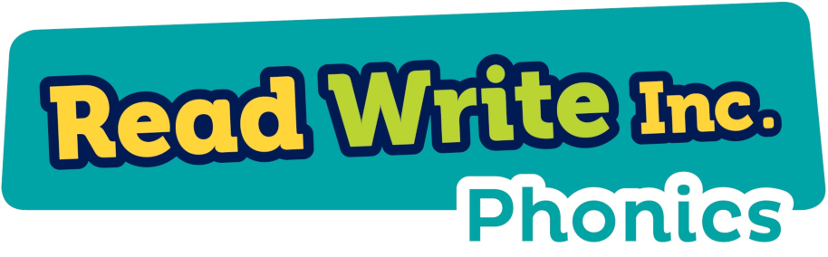
Phonics at Whitley Park
At our school, we understand that a strong foundation in phonics is essential for children’s early literacy development. We are proud to use the Read Write Inc. (RWI) phonics scheme to support our children in developing the crucial skills they need for reading. By embedding phonics into our curriculum, we ensure every child receives the support they need to become confident and fluent readers and writers.

Our Intent
We aim to ensure that every child develops strong phonics skills, enabling them to:
- Read fluently with understanding.
- Spell with accuracy and confidence.
- Build a foundation for learning across the curriculum.
Our goal is for all children to leave Whitley Park as confident readers and writers, able to decode words and spell accurately.

How We Implement Phonics
We implement phonics through:
- Ability groupings: children are streamed into ability groups, ensuring appropriate levels of support and challenge.
- Daily phonics sessions: interactive, engaging lessons where children learn to blend sounds for reading and segment sounds for writing.
- Reading practice: Children read books matched to their phonics level, ensuring immediate success and progress.
- Regular assessments: to track progress and adjust groups accordingly, allowing us to provide targeted tutoring interventions during the school day where necessary.

Phonics and the Wider Curriculum
Phonics is foundational for all subjects. Strong phonics skills support:
- Vocabulary and comprehension in reading across the curriculum.
- Writing skills for all subjects.
- Fluency in learning, making it easier for children to engage with content in other areas.

Phonics Screening Check
The Phonics Screening Check is a national Year 1 assessment to ensure children can decode words by blending sounds. The check contains 40 words to assess children’s ability to decode real words and pseudo-words.
For more information on the screening check please visit the government website: https://www.gov.uk/government/publications/phonics-screening-check-information-for-parents/phonics-screening-check-2024-information-for-parents-text-only-version
For information and resources to assist with home learning please visit the Read Write Inc. parents and carers information page: https://www.ruthmiskin.com/parentsandcarers/

