 | Autumn 1 | Autumn 2 | Spring 3 | Spring 4 | Summer 5 | Summer 6
Reception Handwriting Progression
Resources and activities to support the teaching of handwriting  Handwriting practise should build over the reception year to happen daily by Spring term Included in this there should be a minimum of 3 x 15-minute taught sessions (to include teacher modelling).  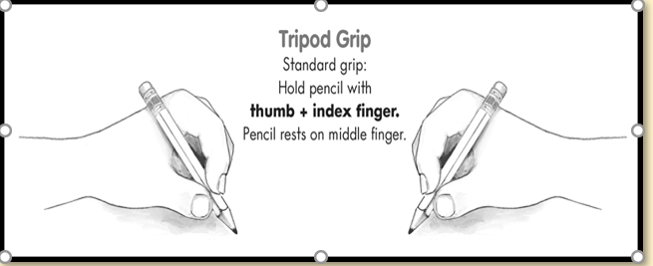 | 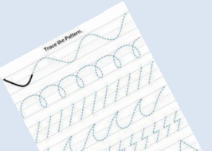  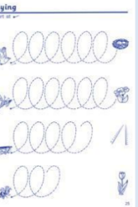  Opportunities to mark make on large scale and on vertical surfaces  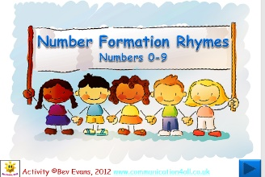  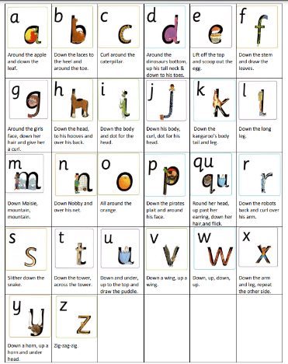  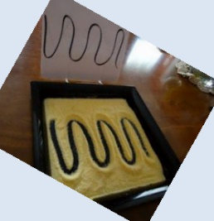 |  | 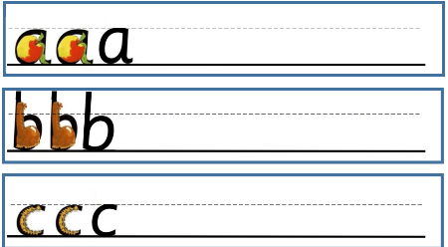  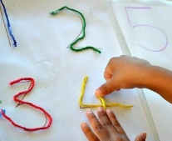  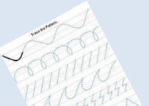  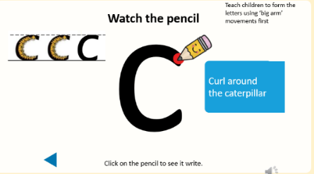  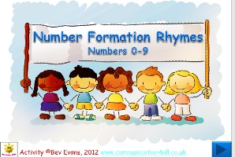  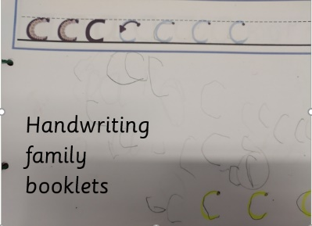  Pre-letter patterns  Good posture  Correct pencil grip visuals |  | 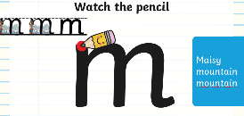  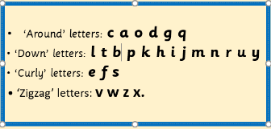  Continue to practise letter formation in letter families  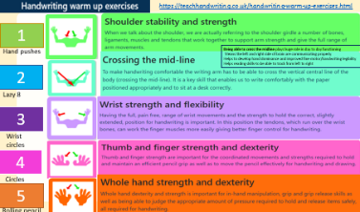  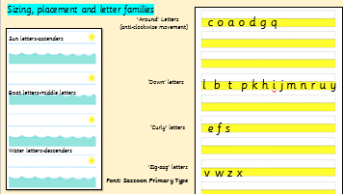    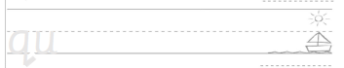  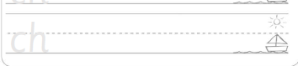  Use sun, boat, water model to practise writing digraphs
Provision/  supporting activities | - Allow children to develop their dominant hand for mark making  - Engage in a range of gross and fine motor activities  - Pencil grip and pressure-range of tools and paper/surfaces available  - Tracings and threading  - Warm up activities to promote shoulder, wrist and finger strength and crossing the mid line  - Write on plain paper |  | - Rehearse letter writing in the air using letter families powepoints using correct sequence of movements  - Left to right orientation, maizes/tracing/Top to bottom patterns  - Warm up activities to promote shoulder, wrist and finger strength and crossing the mid line. Focus on posture  - Introduce lined paper-focus to stay on line and finger spacs  - c-v-c words to practise /sentence of week |  | Introduce Sun, boat and water letters when modelling  Use of yellow highlighted line to support with letter sizing where appropriate  Sentence of week | Early Learning Goal  - Hold pencil effectively in preparation for fluent writing-using tripod grip in almost all cases  - Write recognisable letters, most of which are correctly formed
Focus  Letter formation | Writing own name  Patterns-lines and anti-clockwise movements  Number formation rhymes | Writing name-focus on capital at beginning of name  Model anti-clockwise movements  Write/trace/copy numbers to 3 | The Around Letters  c, a, o, d, g, q  suggested words to practise writing: dog, cog  Write/copy/trace to 5 | The Down letters  l, t, b, p, k, h, i, j  suggested words to practise:  bat, cot, job, hat, cat, hid, bit  Write/copy/trace to 5 | Down letters and Curly letters  m, n, r, u, y e, f, s  words to practise: man, nod, my, run, mum, sun, fun, hot  Write/copy/trace to 10 | Zig-zag Letters  v, w, z, x  and digraphs  sh, ch, th, qu, ng, nk  Write/copy/trace to 10
RWInc  Focus on sound discrimination | Children are taught their Set 1 sounds m, a, s, d, t, i, n, p, g, o, c, k, u, b, f, e, l, sh, h, r, j, v, w, x, y, z, | Recap on set 1. Learn special friends: th, ch, qu, ng, nk Children are taught to blend sounds into words orally. Children are taught to blend single-letter sounds (word time 1.1-1.4) | Recap on set 1 special friends: th, ch, qu, ng, nk Secure blending of words with special friends (word time 1.5 and 1.6). | Recap on any set 1 sounds (addressing sound gaps). Secure blending on words containing all set 1 sounds Children are taught to blend words containing 4/5 sounds and consonant blends (word time 1.6 and 1.7). To be exposed to some common exception words: put, the, I, no, of, my, for, he | Children are taught their set 2 sounds: ay, ee, igh, ow, oo, oo, ar, or, air, ir, ou, oy To recall previous common exception words and be exposed to new common exception words: your, said, you, be, are | Children are taught their set 2 sounds: ay, ee, igh, ow, oo, oo, ar, or, air, ir, ou, oy Children are taught to blend words containing set 2 sounds Children to build speed of reading words containing set 1 sounds Say a sound for each letter in the alphabet and at least 10 digraphs: sh, ch, th, qu, ng, nk ck, ll, ss, ff.
 | Autumn 1 | Autumn 2 | Spring 3 | Spring 4 | Summer 5 | Summer 6
Year 1 Handwriting Progression
Resources and activities to support the teaching of handwriting  Handwriting practise should happen daily. Included in this there should be a minimum of 3 x 15-minute taught sessions (to include teacher modelling / marking / celebrating). | 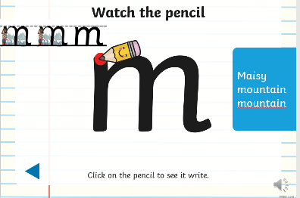  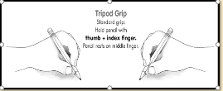  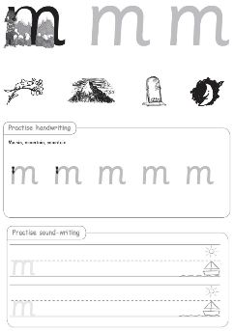  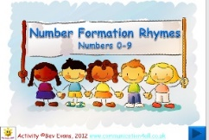 |  | 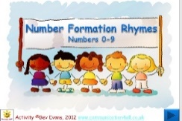  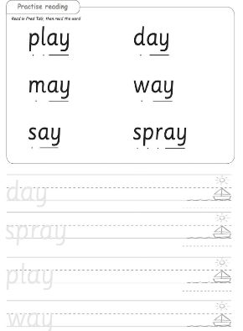  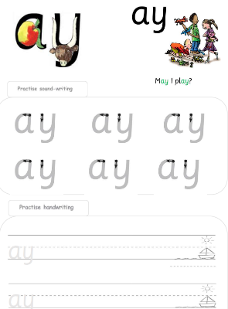  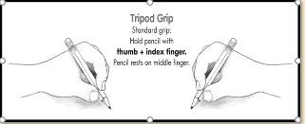 |  | 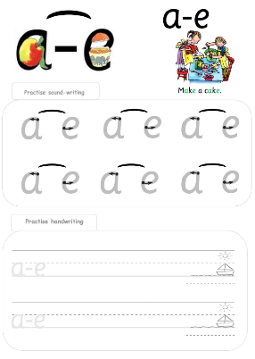  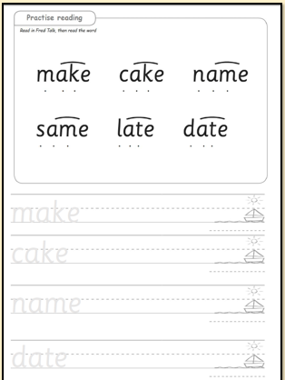  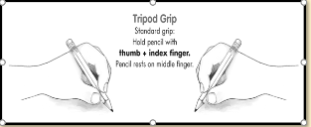
Supporting activities | Consolidate conventional tripod grip  Good posture  Gross and Fine motor activities-cutting/threading/dough  Pre-writing patterns  Begin to form lower case letters in the correct direction, starting and finishing in the right place  Name writing with control over size and orientation |  | As for Autumn term +  Develop appropriate pressure, size, control, orientation and direction of movements  Write first and surname  Form digits 0-9 correctly |  | Understand which letters belong to which handwriting family  Develop
Focus:  Letter formation, size and position of letters on line | Sizing and positioning of letters. on line using ‘boat letters’ (middle letters)  Zig-zag Letter family formation  v, w, z, x  Link to spelling | Sizing and positioning of letters on line using ‘Around’ Letters to include ‘sun letters’ (ascenders) and ‘water letters’ (descenders)  The Around Letter family  c, a, o, d, g, q  Link to spelling | Sizing and positioning of letters on line using ‘Around’ Letters to include ‘sun letters’ (ascenders) and ‘water letters’ (descenders)  The Down letters family  l, t, b, p, k, h, i, j  Link to spelling | Sizing and positioning of letters on line using ‘Around’ Letters to include ‘sun letters’ (ascenders) and ‘water letters’ (descenders)  Down letters and Curly letters  m, n, r, u, y e, f, s  Link to spelling | Set 2 and 3 digraphs and trigraphs letter formation practise  Link to spelling  Copying sentence/list/poem/  Dictation of simple sentence
RWInc | Children are taught their set 2 sounds: ay, ee, igh, ow, oo, oo, ar, or, air, ir, ou, oy Children are taught to read words containing set 2 sounds. Children build speed of reading words containing set 1 sounds, particularly word time 1.6-1.7. | Review set 2 sounds, particularly: ar, or, air, ir, ou, oy Children build speed of reading words containing these set 2 sounds: ay, ee, igh, ow, oo, oo Children are taught set 3 sounds: ea, oi, a-e, i-e,o-e, u-e, e-e | Children to build speed of reading words containing these sounds set 1,2 and the following set 3 sounds (ea, oi, a-e, i-e,o-e, u-e, ee). Children are taught the rest of the set 3 sounds. | Children to build speed of reading words containing set 1, 2 and 3 sounds. Begin to read multisyllabic words, including words with suffix endings. | Children to build speed of reading words containing set 1, 2 and 3 sounds. Read multisyllabic words with increased accuracy. | Children to read words containing set 1, 2 and 3 sounds speedily. Read multisyllabic words with increased accuracy and pace.

 | Autumn 1 | Autumn 2 | Spring 3 | Spring 4 | Summer 5 | Summer 6
Year 2 Handwriting Progression
Resources and activities to support the teaching of handwriting  Handwriting practise should happen daily. Included in this there should be a minimum of 3 x 15-minute taught sessions teacher modelling / marking / celebrating).  Some children will be targeted for more intensive intervention. | 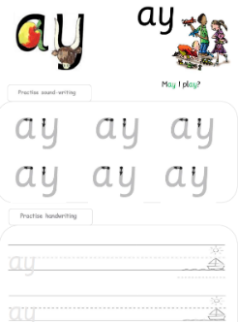  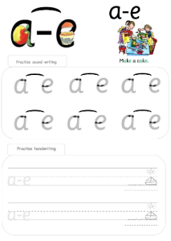 |  | 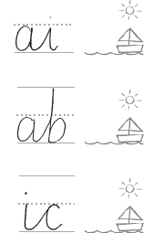  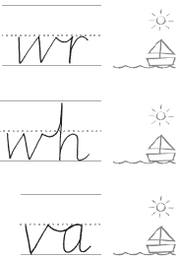  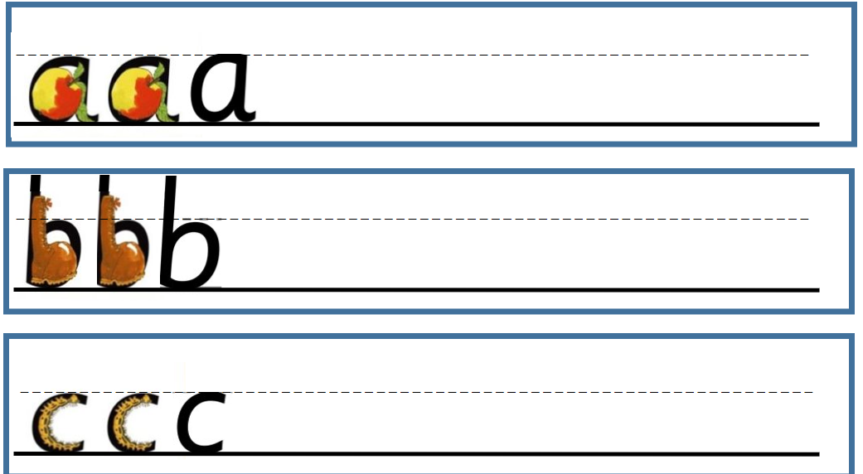 |  | Match and copy captions  • Trace and copy patterns  • Copy words  • Copy sentences  • Write out menu  • Copy poem  • Alphabetical ordering | 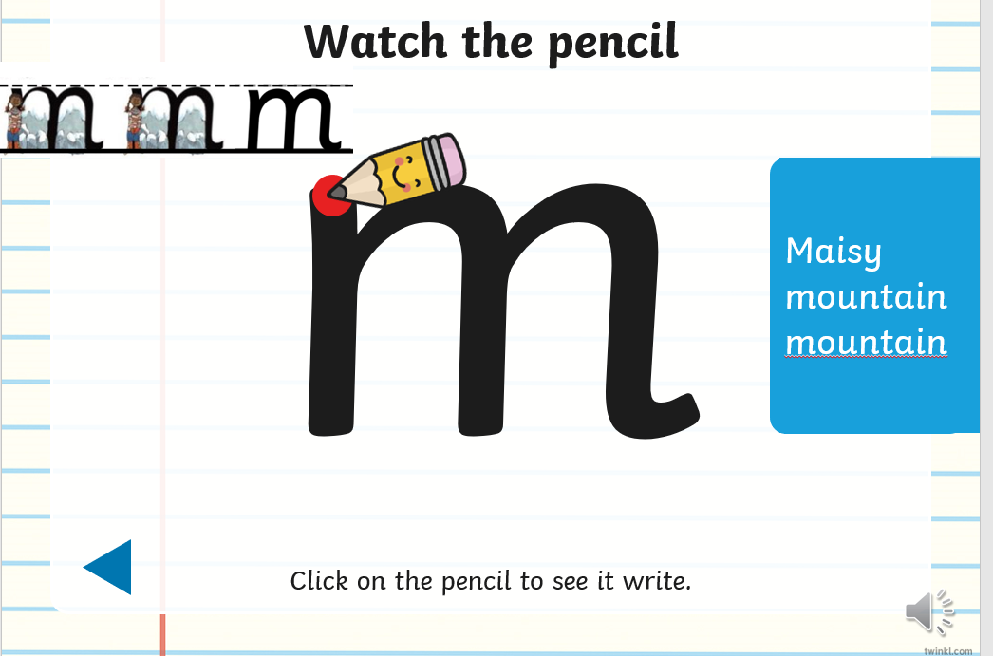
Supporting activities |  |  |  |  |  | Uses spacing between words
Focus | Review and consolidate letter formation of lower- and upper-case letters within the 4 letter family groups:  The Around Letter family c, a, o, d, g, q  The Down letters family l, t, b, p, k, h, i, j m, n, r, u, y  The Curly letters e, f, s and Zig-zag v, w, z, x  Practise handwriting in conjunction with phonic and spellings |  | First join- to letters without ascenders: un um ig id ed eg an or ing ung  Practise handwriting these in conjunction with phonic and spelling patterns | Second join- to letters with ascenders: ch sh th tl ll ill sli slu ck ack st sti ink unk  Practise handwriting these in conjunction with phonic and spelling patterns | Third join- horizontal joins-  od pg re ve oon oom  Practise handwriting these in conjunction with phonic and spelling patterns | Forth join -Horizontal joins to letters with ascenders: wl vl of ff fl flo  - Practise the break letters b p g q y j z  - Practise capital letters  - Form letters of the correct size relative to one another
RWInc | Children to read words containing set 1, 2 and 3 sounds speedily. Read multisyllabic words accuracy and pace. | Recap any missing sound gaps and build fluency when reading stories. Read multisyllabic words accuracy and pace | Read all words including nonsense and multisyllabic words that include set 1,2,3 sounds speedily and accurately. Children on track for expected will complete the programme at the end of Spring 1. | Children are encouraged to read a range of text types (fiction, non-fiction, poetry, rhymes). Daily opportunities for children to build pace and fluency of reading. Learn how and when to use expression in reading. Children to read multisyllabic words and words with suffix endings. Children to read topic related vocabulary. Children to read year 2 common exception words.

